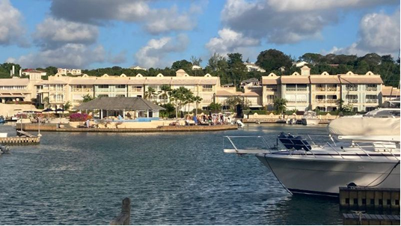

April 2025
PORT St CHARLES
As many people are heading home there are a few items we would like to share.

Sunset Isle
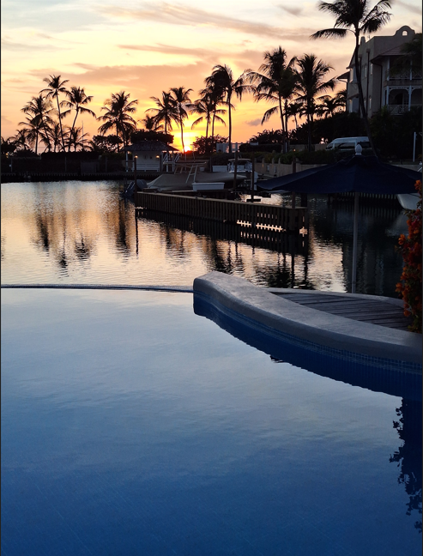

Ryan’s first season at the Sunset Isle has been very successful!
He has agreed to keep the bar open for four days a week Thursday to Sundays from 1st May 2025 though the summer period and will reopen fully again in November 2025.
Thank you to all the people who supported the Sunset Isle.
The majority of the feedback we have had has been very positive.
If you have any suggestions for changes or improvements, please forward them to:
info@psc-cs.com
Boat Owners

For Boat Owners - please note that the boat license requirements have changed.

- Holders of speed boat licenses can now collect their new Small Craft Operator license from Floor 4 at the Ministry of Tourism, Warrens.
You will need your old license, ID and a photo taken.
- Renewal of your boat permit if registered in Barbados.
- You will now be issued a credit card like license for your boat - Small Commercial Craft Registration. Your operator’s license references your boat registration - they are tied together.

You will need:
  - Your new operator’s license
  - Your insurance
  - Your marine survey
  - Your passport.
  - Have your photo taken
  - Pay $100

This means you must on this first registration - do it in person!
You cannot do this in absentia. Those leaving soon might want to take this into consideration and do both at the same time.

Sandals Development Speightown

You will have noted that Sandals have begun demolition at their property next door. Some residents have requested information. Alan Birkett, our COO, has been able to access the plans. His comments follow. Please note - these plans have been approved by Barbados authorities and are not open to change or discussion.

The buildings (most of them) will be seven (7) stories tall.
Sandals are stepping back from their Northern boundary to allow space to increase the size of the public car park which would have been a prerequisite from the government.
The entire stretch along their Northern boundary will be buildings for accommodation.
To the south of the said building is a car park and closer towards the beach a pool.
The restaurant cluster is located along the Speightstown bypass road and is a good distance away from the buildings.
All traffic enters and exits the main entrance which is nowhere near us.
The central facilities, conference rooms etc. are located south of the center of the property, this is also where the tennis courts etc. are located.
The water park will be located in the middle of the property.

We will be bolstering our planting along our border with fast growing dense plants to mitigate any extra noise, although in Alan’s opinion there is nothing on our border which should negatively impact our property.

Outstanding Employee - Jason Johnson

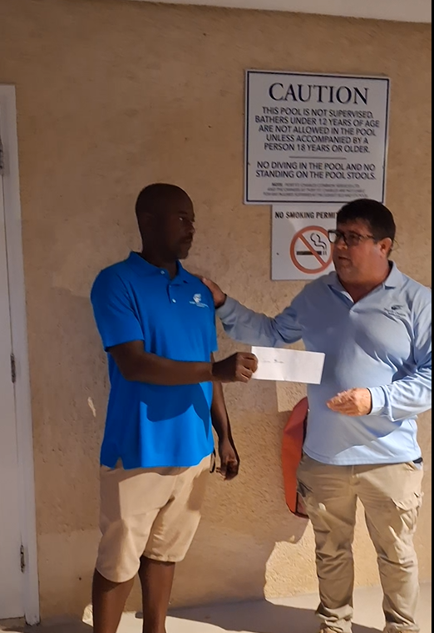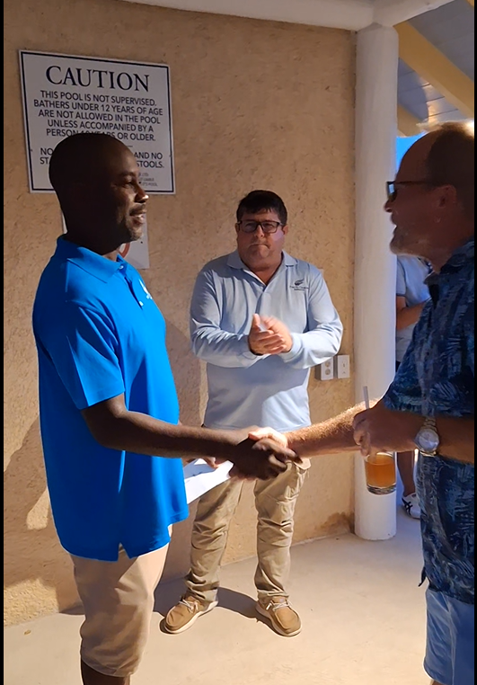

Jason was recognized at our last cocktail party for an act of heroism - rescuing two people who were in danger of drowning.

Thank you from all of us at Port Saint Charles!

We are very lucky to have many staff members who will go above and beyond the call of duty - this is not the first time staff members have acted selflessly to help other people. We thank all who has done so as well as Jason and we hope if you witness any extraordinary behaviour from a member of our team you will bring it to the attention of management or the board.

Goodbye & Hello!


Greta Lorde our Landscaping Supervisor retired at the end of March 2025, after almost 20 years with Port St, Charles! She was a will remain valued member of PSC. She has a wide and broad knowledge of all plants and landscaping and we are very fortunate that she will not be leaving us entirely as the Nursery Propagation Project will have her expertise for two day a week, providing plants and flowers to be seen around the property.
Your dedication and hard work have made a real difference, we appreciate you Greta!

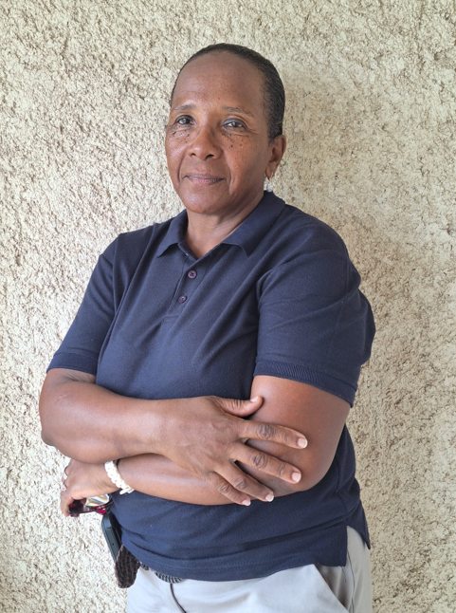
We also welcome Nelcia Nicholls as our new Landscaping Supervisor, who bring her vast experience of plants and team management to Port St Charles. We wish them all the best!
Painting by Block

In the ongoing efforts to maintain the highest of standards of maintenance at Port St. Charles, commencing Monday 5th May 2025 the following two blocks, in their entirety will be undergoing external painting.

- The Island: #132, 133, 134, 135, 235, 136, 236, 336, 139, 239, 339, 140, 240, 141, 142, & 143
- PUP 64: #159, 259, 359, 160, 260, 360

We estimate the painting should be completed within 6-8 weeks.
Please plan accordingly!
A scheduling of painting for the entire property is currently being finalised.

Other Major Maintenance

We are in the planning stages for up to 4 Replacement Elevators & 1 Generators before the end of this year, as most are near the end of their economic life spans.
A plan for major infrastructure replacement will be shared when it has been fully approved by the Board.

PSC Renovations Reminder

1st May to 15th October 2025
By Application only
email info@psc-cs.com

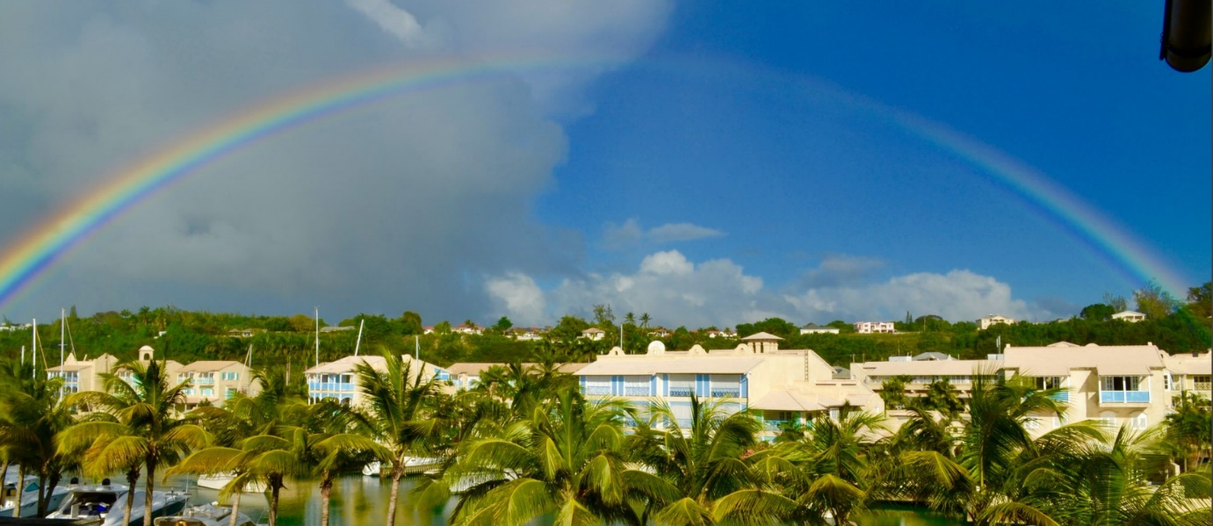

Cocktail Parties

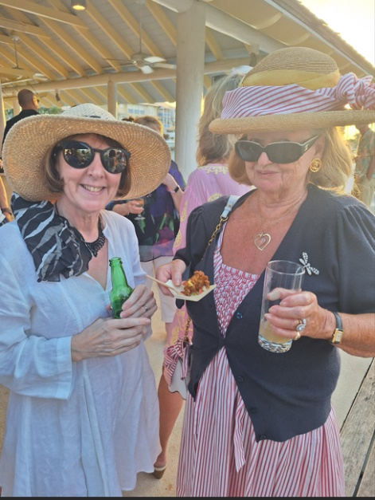
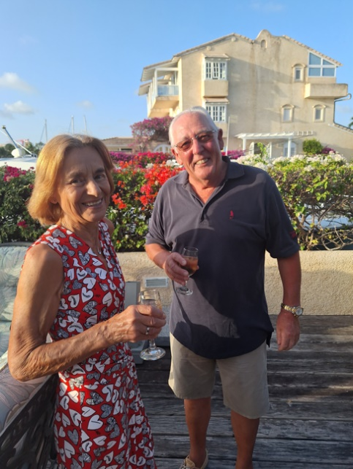
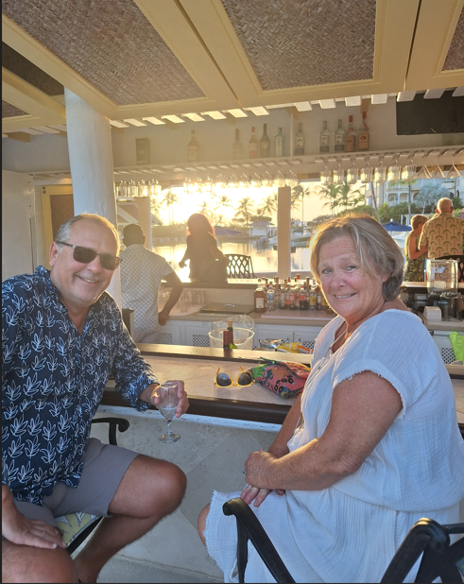
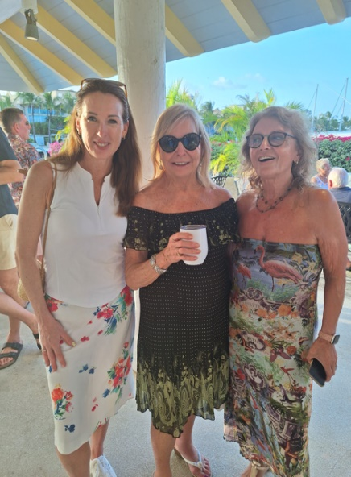
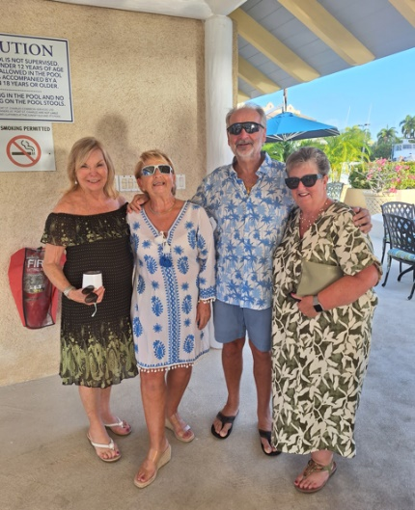
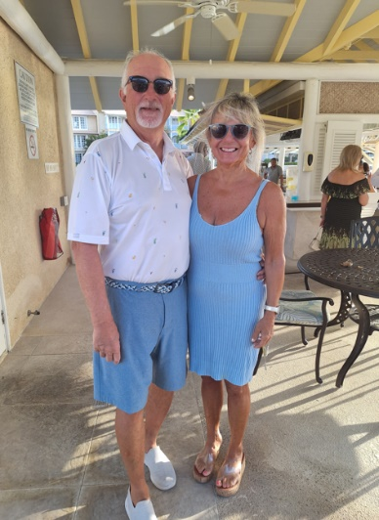
This season we hosted 3 events, all were well attended and enjoyed by all!

